Combating Early Investing Barriers Using Machine Learning Among Kenyan University Students

AUTHOR: ELKANAH MOGAKA OMARI
SCT221-0260/2020

SUPERVISOR: MR. JOMO NJENGA

AFFILIATION
A research proposal submitted to the Department of Information Technology in the School of College of Pure and Applied Sciences in partial fulfillment of the requirements for the award of the degree of Bachelor of Science in Information Technology, Jomo Kenyatta University of Agriculture and Technology.
YEAR: 2025

DECLARATION

This proposal/research project is my original work and has not been presented for a
degree in any other University

…………………………………………………………..
Signature
…………………………………..……………………….

Date: 2025/AUGUST

This proposal/research project has been submitted for examination with my approval
as University Supervisor
……………………………………………………………
Signature
……………………………………………………………..
Abstract
Early engagement with financial markets is crucial for long-term wealth creation, yet Kenyan university students face significant obstacles to investing. These include limited financial literacy, lack of accessible educational resources, complex platform interfaces, and behavioral biases such as fear of loss and short-term thinking. This project aims to address these challenges by developing a machine learning–driven financial literacy platform tailored to the needs of university students.
The proposed solution integrates educational modules, portfolio tracking, and intelligent feedback mechanisms to guide users through their investing journey. Machine learning will be employed to personalize content delivery, assess user risk profiles, and provide behavioral nudges that promote consistent and informed investing.
The project will follow an Agile development methodology to allow iterative refinement based on user feedback and data insights. Key components will include user-centered design, behavioral modeling, and financial data analysis.
Expected outcomes include a fully functional platform that mitigates educational, behavioral, and structural barriers to investing. The system will empower students to manage their portfolios effectively, make informed financial decisions, and build foundational investing habits. Ultimately, the platform seeks to elevate financial literacy and foster a culture of early, confident participation in financial markets among Kenyan university students.

CHAPTER 3: SYSTEM ANALYSIS AND DESIGN

Contents
CHAPTER 3: SYSTEM ANALYSIS AND DESIGN 4
3.1 INTRODUCTION 5
3.2 SYSTEMS DEVELOPMENT METHODOLOGY 6
3.3 FEASIBILITY STUDY 7
3.4 REQUIREMENTS ELICITATION 10
3.5 DATA ANALYSIS 13
3.6 SYSTEM SPECIFICATION 20
3.7 REQUIREMENTS ANALYSIS AND MODELLING 22
3.8 LOGICAL DESIGN 27
3.9 PHYSICAL DESIGN 45
REFERENCES 66
LIST OF TABLES 68
LIST OF FIGURES 68

3.1 INTRODUCTION
This chapter describes the system analysis and design aspects of the proposed solution. It outlines the methodology adopted for system development and the thinking behind its selection and how it aligns with the previously mentioned research objectives. It also provides a structured foundation for implementation by detailing the approach to system development that emphasizes on key factors like adaptability, scalability and user centered design. It introduces the methodology used for development chosen for this study and explains how it supports the creation of a financial literacy and investing platform tailored to Kenyan university students.
The key areas covered in this chapter will include the systems development methodology guiding the research, the justification for selecting this methodology and how the methodology informs subsequent stages of system design and implementation.

3.2 SYSTEMS DEVELOPMENT METHODOLOGY
For this research, the Agile Development Methodology is adopted. It emphasizes iterative development, stakeholder collaboration and responsiveness to change together with the qualities that are relevant for this project. Agile was first articulated in the Manifesto for Agile Software Development (Beck et al., 2001), which highlighted values such as individuals and interactions, working software, customer collaboration, and responsiveness to change. These principles are especially important in the context of financial literacy platforms, where user needs evolve rapidly and continuous feedback is essential. Cockburn and Highsmith (2001) emphasize that Agile is fundamentally about the people factor, underscoring collaboration and adaptability as central to successful system development. Similarly, Cockburn and Williams (2003) argue that Agile thrives on feedback and change, making it suitable for projects where requirements are dynamic and uncertain, such as tailoring financial education to diverse student populations. Recent scholarship continues to validate the relevance of using Agile. Noteboom, Ofori, Sutrave, and El‑Gayar (2021) identify critical success factors for Agile adoption, including stakeholder involvement and iterative prototyping, both of which align with the proposed design philosophy. Behrens, Ofori, Noteboom, and Bishop (2021) further note that Agile project management remains highly adaptable, allowing systems to evolve in response to contextual realities.
The justifications for the use of the Agile methodology are as follows:
1. User-centered design: Agile allows continuous feedback from students and stakeholders, ensuring the platform remains relevant and intuitive. (Cockburn & Highsmith, 2001).
2. Flexibility: Financial literacy needs vary across users; Agile supports iterative refinement of modules such as budgeting, saving, and investing (Cockburn & Williams, 2003).
3. Rapid prototyping: Early versions of the platform can be tested and improved incrementally, reducing risks of misalignment with user expectations (Beck et al., 2001).
4. Scalability: Its modular approach supports future integration of advanced features like behavioral nudging and machine learning–driven personalization (Noteboom et al., 2021; Behrens et al., 2021).

3.3 FEASIBILITY STUDY
The feasibility study evaluates the practicality of implementing the financial literacy and investing platform. It examines the economic, technical, operational, and regulatory aspects to determine whether the project can be successfully developed and sustained. The analysis confirms that the project is both viable and strategically aligned with the needs of Kenyan university students.
3.3.1 ECONOMIC FEASIBILITY
Economic feasibility assesses whether the benefits of the platform outweigh the costs of development and maintenance. The following are some of the crucial items to be considered:
1. Development Costs: By leveraging open-source tools, cloud-based services, and free prototyping frameworks, upfront expenditure is minimized.
2. Operational Costs: Hosting and maintenance can be managed through scalable cloud solutions, with costs adjusted to user growth.
3. Revenue/Support Model: Sustainability may be achieved through partnerships with financial institutions, grants for educational technology, or minimal subscription fees.
4. Benefit Analysis: Improved financial literacy among students reduces long-term risks of poor financial management, creating social and economic value.
Project appraisal literature emphasizes that cost-benefit analysis and social return on investment are critical in determining economic feasibility (Unit 16 Project Appraisal, 2021). In Kenya, digital financial services have already demonstrated significant economic impact by expanding access and reducing transaction costs (Kamau, Misati, Ngoka, Odongo, & Were, 2023).

3.3.2 TECHNICAL FEASIBILITY
Technical feasibility evaluates whether the required technology and expertise are available.
The following are some of the crucial items to be considered:
1. Technology Stack: The platform can be built using widely adopted frameworks (Python/Django for backend, React for frontend, and machine learning libraries such as TensorFlow or Scikit-learn).
2. Infrastructure: Cloud hosting (AWS, Azure, or local providers) ensures scalability and reliability.
3. Integration: APIs enable integration with mobile money services (e.g., M-Pesa) and financial data sources.
4. Expertise: The project team should possess knowledge in distributed systems, AI, and platform design, ensuring technical competence.
Feasibility studies in ICT projects highlight that technical feasibility depends on available infrastructure, compatibility with existing systems, and developer expertise (Katimuneetorn, 2008). Kenya’s high mobile penetration and digital adoption further strengthen technical viability (Tiony & Yin, 2023).
3.3.3 OPERATIONAL FEASIBILITY
Operational feasibility considers whether the system can function effectively in its intended environment. The following are some of the crucial items to be considered:
1. User Adoption: University students are digitally literate and accustomed to mobile applications, increasing likelihood of adoption.
2. Training and Support: Minimal training required due to intuitive design; user guides and in-app tutorials can support onboarding.
3. Stakeholder Involvement: Collaboration with universities, student associations, and financial literacy NGOs ensures relevance and trust.
4. Maintenance: Agile methodology supports continuous updates and responsiveness to user feedback.
Operational feasibility is often determined by stakeholder readiness and organizational alignment (Toronto CS Lecture Notes, 2005). In Kenya, digital platforms have proven effective as delivery channels for financial literacy, enhancing operational feasibility for The platform (Boldar, Omanwa, & Baimwera, 2022).
3.3.4 Other Feasibility Aspects
1. Legal and Regulatory Feasibility: Compliance with Kenyan data protection laws (Data Protection Act, 2019) and financial regulations ensures legitimacy.
2. Social Feasibility: The platform addresses a pressing social need — empowering youth with financial literacy — which enhances acceptance and impact.
3. Environmental Feasibility: Cloud-based infrastructure reduces physical resource requirements, aligning with sustainable practices.
Based on the economic, technical, operational, and regulatory analyses, the platform is feasible and sustainable. The project can be implemented with manageable costs, available technology, and strong stakeholder support. Its alignment with student needs and national priorities in financial inclusion further strengthens its viability as a project being pursued.

3.4 REQUIREMENTS ELICITATION
Requirement elicitation is a critical stage in system analysis and design, ensuring that the developed system reflects user needs and research objectives. For The platform, requirements elicitation involved using Google Forms questionnaires, and observation. This combination provided both primary and secondary insights, ensuring that the requirements deduced were comprehensive, reliable, and contextually relevant.
3.4.1 Data Collection Tools
- Google Forms Questionnaire
A structured questionnaire was designed and administered using Google Forms. This tool was selected because it is free, accessible, and allows for both quantitative and qualitative data collection. The questionnaire included:
  - Multiple-choice questions for demographic data (e.g., year of study).
  - Multiple-choice grid for financial activities (budgeting, saving, investing, borrowing, mobile money usage), rated on a frequency scale (Never → Very Often).
  - Linear scale questions (Likert-style) to measure confidence in financial management and importance of features such as security, usability, and integration with M-Pesa.
  - Open-ended questions to capture qualitative insights (e.g., “What one improvement would you suggest for a financial literacy platform designed for students?”).
The questionnaire was prepared in consultation with the supervisor to ensure validity and relevance, pre-tested with a small group of students, and then distributed electronically via email and WhatsApp groups. A copy of the questionnaire is attached as an appendix.
- Observation
Direct observation was conducted to study how students interact with existing financial applications (e.g., Chumz, Kuza) and informal saving practices. This method provided qualitative insights into usability challenges, behavioral tendencies, and contextual factors influencing financial decision-making.
3.4.2 Sampling Techniques
- Sampling Method: Stratified random sampling was used, dividing the population into strata based on university more than by year of study. This ensured diversity in perspectives and representativeness of the sample.
- Sample Size Determination: The sample size was calculated using Yamane’s formula (1967) for finite populations:
n = N/ [1 + N(e^2)]
Where:
- (n) = sample size
- (N) = population size (total number of students in target universities)
- (e) = margin of error (set at 5%)
This formula provided a statistically valid sample size, balancing accuracy with feasibility that led to the accumulation of 18 responses from participants from different Years and Universities in Kenya.
3.4.3 Relevance to Research Objectives
The data collected was directly aligned with the research objectives:
- Identifying gaps in financial literacy among students.
- Understanding behavioral tendencies in saving and investing.
- Assessing usability challenges in existing fintech platforms.
- Capturing stakeholder expectations for a student-centered financial literacy platform.
This ensured that the elicited requirements were not only technically sound but also socially and contextually relevant.
3.4.4 Deduction of System Requirements
The insights gathered informed both:
- Functional requirements (e.g., account creation, budgeting tools, investment simulations, nudging mechanisms).
- Non-functional requirements (e.g., security, scalability, usability).
The iterative nature of Agile methodology allowed these requirements to be refined continuously based on stakeholder feedback.

3.5 DATA ANALYSIS
Data analysis was conducted to interpret the information collected during requirements elicitation and to deduce system requirements for the platform. The analysis employed statistical tools and graphical representations to ensure clarity, accuracy, and relevance to the research objectives.
3.5.1 Analytical Tools
- Google Forms: The primary tool used for data collection and analysis. Google Forms automatically generates summary charts (pie charts, bar graphs, and linear scales) for each question, providing immediate visualization of responses.
- Excel (optional secondary analysis): Data exported from Google Forms was cleaned and tabulated in Excel to allow for deeper statistical analysis. (Field, A2013).
3.5.2 Data Representation
Each of the eight questionnaire items was analyzed and represented using appropriate charts:
- Demographic Data (Year of Study): Represented using a pie chart to show the proportion of respondents across different years of study.
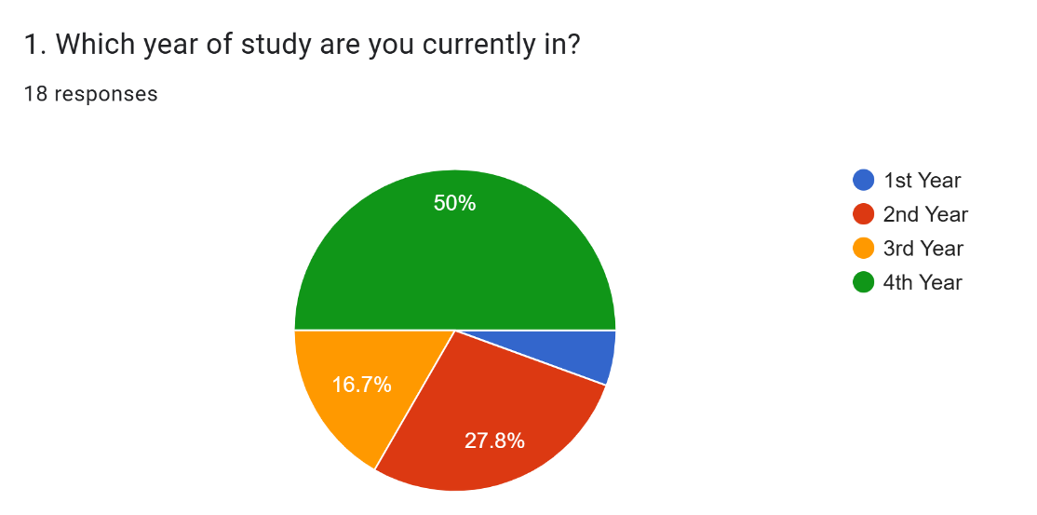
Figure 1: Question 1
- Confidence in Financial Management (Likert/Linear Scale): Represented using a bar graph to display levels of confidence among students. The respondents showed an above average confidence in their ability to manage their finances.
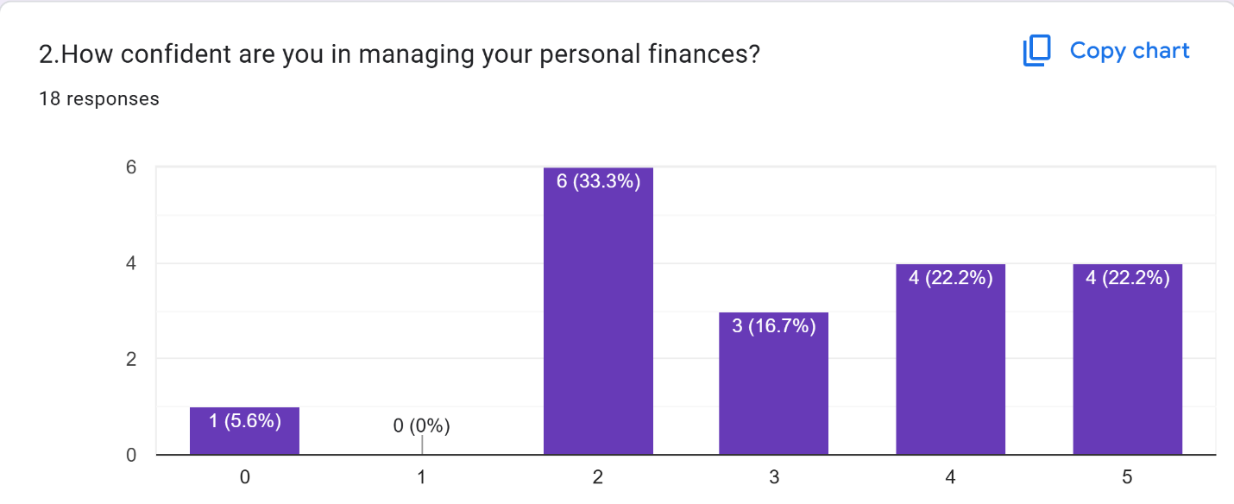
Figure 2: Question 2
- Financial Activities (Multiple-choice grid): Represented using a stacked bar chart, showing frequency of engagement (Low → High) across budgeting, saving, investing, borrowing, and mobile money usage. The respondents showed a low interest in borrowing and moderate budgeting, saving and investing.
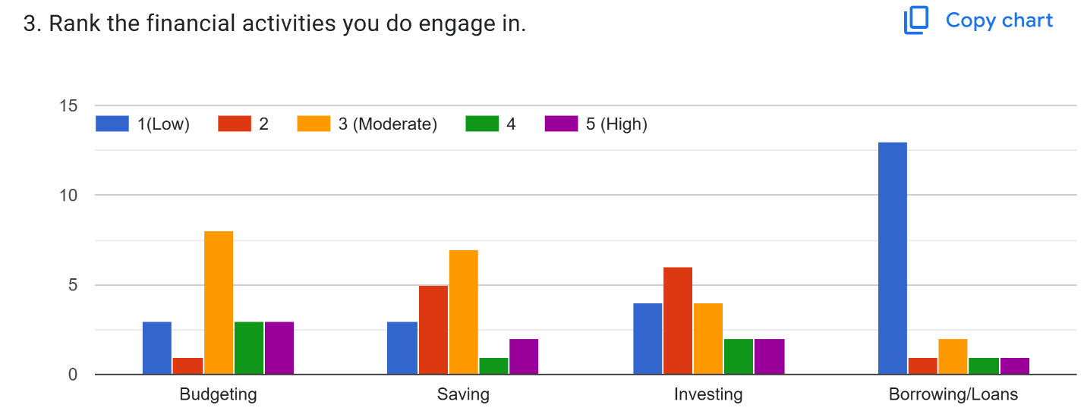
Figure 3: Question 3
- Use of Financial Apps: Represented using a pie chart to show the proportion of students who currently use financial apps. 22% of the respondents do not use any financial apps like Kuza or Chumz while 66.7% do (‘not listed’ + ’yes’).
- 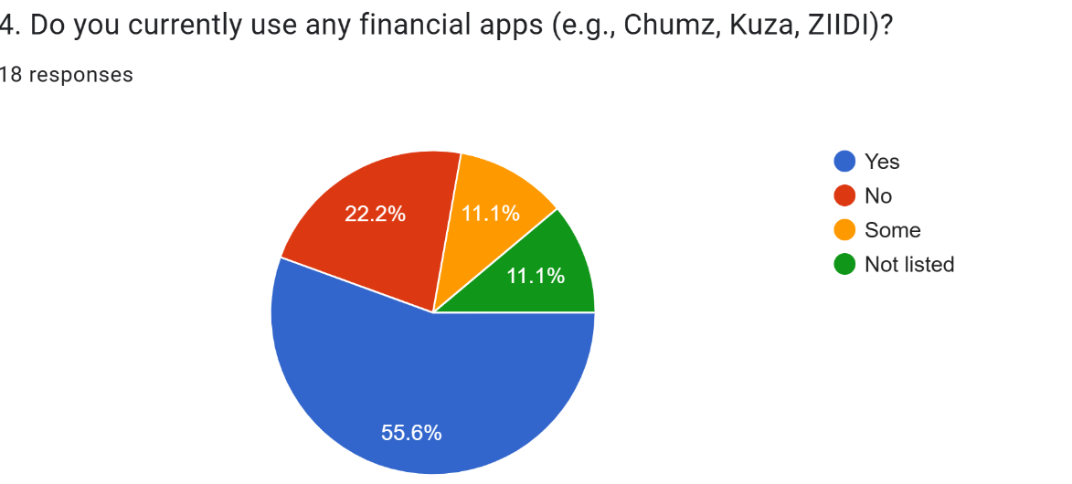
Figure 4: Question 4

- Challenges with Financial Apps (Open-ended): Responses were coded thematically (e.g., usability issues, lack of relevance, security concerns) and summarized in a frequency table.
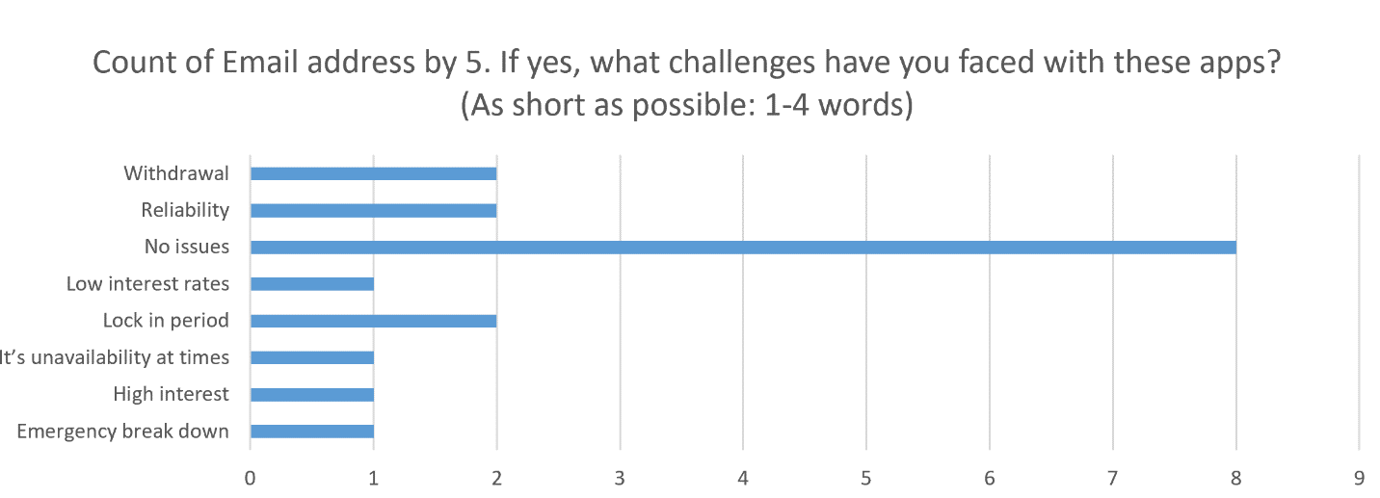
Figure 5: Question 5

- Desired Features (Ranking): Represented using a bar graph to highlight the most preferred features (budgeting tools, saving goals tracker, investment simulations, nudging, peer learning). Respondents chose goal tracking unanimously as the most desired feature.
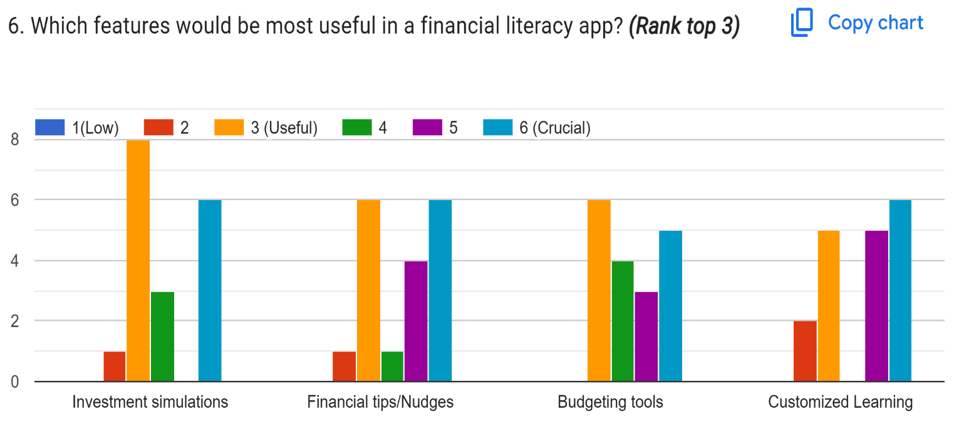
Figure 6: Part 1, Question 6
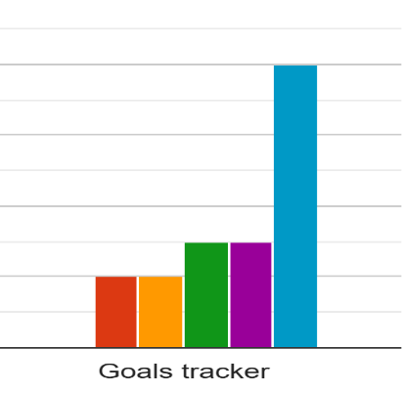
Figure 7:Part 2, Question 6
- Importance of App Aspects (Likert/Linear Scale): Represented using a bar graph to show ratings of usability, security, local relevance, and integration with M-Pesa.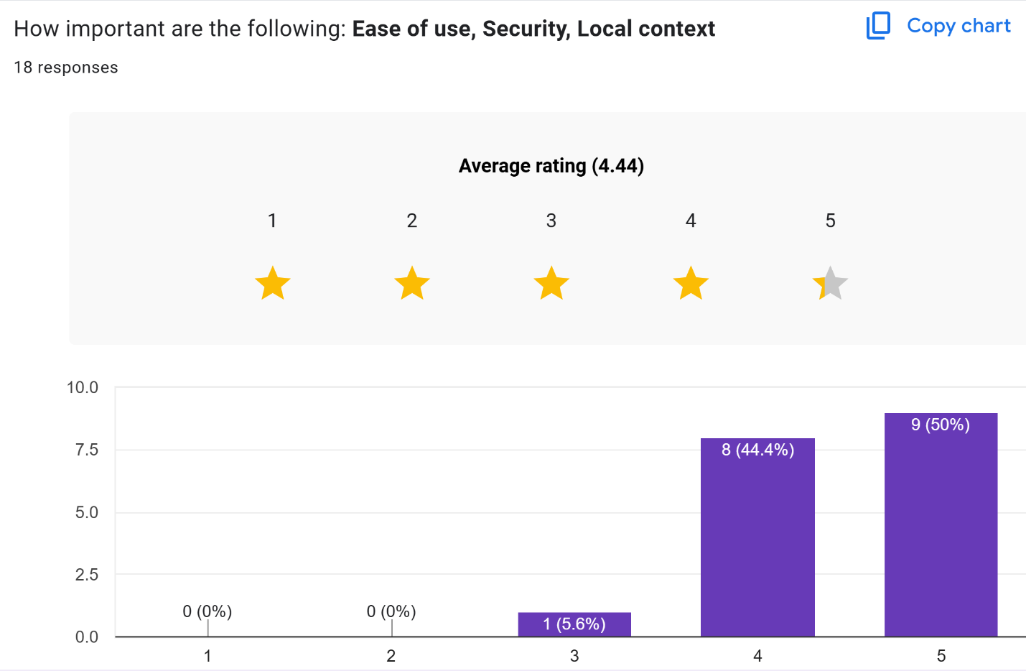
Figure 8: Question 7
- Final Suggestions (Open-ended): Responses were analyzed qualitatively and grouped into themes.
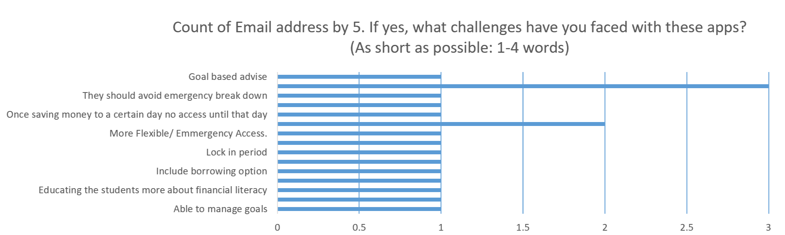
Figure 9: Question 8
3.5.3 Findings
The analysis revealed several key insights:
- Higher engagement in saving and mobile money usage than investing, indicating the need for investment simulations and nudging features.
- Moderate confidence in financial management, suggesting the platform should include educational modules and guided tools.
- Usability and security emerged as the most important non-functional requirements.
- Students expressed challenges with existing apps, including poor user experience, reinforcing the need for a student-centered design.
- Desired features prioritized budgeting tools and saving trackers, confirming their centrality to the platform’s functional requirements.
3.5.4 Deduction of Requirements
The data analysis directly informed system requirements:
- Functional Requirements: Budgeting tools, saving goals tracker, investment simulations, financial nudges, and peer learning features.
- Non-functional Requirements: High usability, strong data security, contextual relevance to Kenyan students, and seamless integration with mobile money services.

3.6 SYSTEM SPECIFICATION
System specification defines the detailed requirements that guide the design and implementation of the platform financial literacy and investing platform. These specifications are derived from the feasibility study and requirements elicitation process, ensuring that the system is both functional and contextually relevant to Kenyan university students. The specifications are categorized into functional requirements and non-functional requirements (Sommerville, I. 2016).
3.6.1 Functional Requirements
Functional requirements describe the specific services and features that the system must provide. For the platform, these include:
- User Account Management: Registration and login functionality and profile management (basic details, year of study, financial goals).
- Budgeting Tools: Ability to create, edit, and track personal budgets and provide visualization of income vs. expenditure using charts.
- Savings Goals Tracker: Set and monitor savings goals and provide notifications and nudges to encourage consistent saving.
- Investment Simulations: Have interactive modules to simulate investment scenarios and provide risk-reward analysis tailored to student contexts.
- Financial Literacy Content: Use educational modules covering budgeting, saving, investing, and responsible borrowing and provide gamified quizzes to reinforce learning.
- Behavioral Nudging: Provide personalized reminders and tips based on user activity and provide adaptive nudges informed by machine learning models.
- Integration with Mobile Money Services: Seamless linkage with M-Pesa and other local payment systems and transaction tracking for savings and investments.
- Community/Peer Learning Features: Forums or discussion boards for peer-to-peer financial learning and sharing of success stories and strategies.
3.6.2 Non-Functional Requirements
Non-functional requirements specify the quality attributes and constraints of the system. For the platform, these include:
- Usability: Intuitive interface designed for mobile-first access and clear navigation and minimal learning curve.
- Performance: Fast response times for transactions and simulations and scalable architecture to support growing user base.
- Security: Strong authentication and data encryption and compliance with Kenya’s Data Protection Act (2019).
- Reliability: High system uptime with minimal downtime with robust error handling and recovery mechanisms.
- Maintainability: Modular design to allow easy updates and feature additions and documentation for developers and administrators.
- Portability: Cross-platform compatibility (Android, iOS, web) and Cloud-based deployment for accessibility.
- Localization: Content tailored to Kenyan context (currency in KES, local examples) with support for Swahili and English.
3.6.3 Summary
The system specifications ensure that the platform is both functionally rich and operationally robust. Functional requirements guarantee that the platform delivers budgeting, saving, investing, and literacy features, while non-functional requirements ensure usability, security, and scalability. Together, these specifications provide a comprehensive blueprint for system design and implementation (Sommerville, I. ,2016).

3.7 REQUIREMENTS ANALYSIS AND MODELLING
System design translates the elicited requirements into structured models that clarify functionalities, dependencies, and interactions within the platform. This stage ensures that the system specifications are logically organized, conflicts are resolved, and dependencies are identified before implementation. Visual modeling tools such as data flow diagrams (DFDs), use case diagrams, and class diagrams are employed to represent the system’s architecture and functionalities (Sommerville, 2016; Pressman & Maxim, 2014).
3.7.1 Requirements Analysis
The requirements gathered in Section 3.6 were analyzed to identify:
- Dependencies:
  - Budgeting tools depend on user account management and transaction tracking.
  - Investment simulations depend on financial literacy modules and archived financial data.
  - Nudging mechanisms depend on user activity logs and machine learning models.
- Conflicts:
  - Usability vs. security: Strong authentication may reduce ease of access.
  - Performance vs. scalability: Adding advanced simulations may slow down response times if not optimized.
  - Localization vs. portability: Tailoring content to Kenyan context may require additional effort for cross-platform deployment.
- Potential Solutions:
  - Employ adaptive authentication (balancing usability and security).
  - Use cloud-based microservices to balance performance and scalability.
  - Modularize content delivery to support both localized and portable versions.
This process of analyzing dependencies and conflicts aligns with best practices in requirements engineering, which emphasize early identification of trade-offs to avoid costly redesigns (Kotonya & Sommerville, 1998).
3.7.2 Structuring Requirements into Functionalities
The requirements were structured into major software components:
- User Management Module (registration, login, profiles).
- Financial Literacy Module (educational content, quizzes).
- Budgeting and Savings Module (budget creation, savings tracker, nudges).
- Investment Simulation Module (risk-reward analysis, scenario testing).
- Integration Module (M-Pesa and mobile money APIs).
- Community Module (peer learning, forums).
Structuring requirements into modules ensures traceability and maintainability, consistent with the modular design principles outlined in software engineering literature (Pressman & Maxim, 2014).
3.7.3 Visual Modeling Tools
- Low-Level Data Flow Diagram (DFD):
Illustrates how data moves between modules. For example, user inputs → budgeting module → savings tracker → nudging system. DFDs are widely used to clarify system processes and data dependencies (Sommerville, 2016).
- Use Case Diagram:
Shows interactions between actors (students, administrators, financial institutions) and system functionalities.
  - The Student actor connects to multiple use cases: budgeting, savings, investment simulations, literacy content, nudging, and community.
  - The Administrator actor connects to content management and reporting use cases.
  - All use cases interact with the central database, which stores user data, financial records, and content.

Use case diagrams are particularly effective in capturing functional requirements and actor-system interactions (Booch, Rumbaugh, & Jacobson, 2005).
- Conceptual Class Diagram:
Represents system entities and their relationships. The Conceptual Class Diagram represents the core entities of the Tajirisha platform and the relationships among them. It provides a high-level view of the system’s structure, ensuring that functional requirements are mapped to logical components (Booch, Rumbaugh, & Jacobson, 2005).
  - Classes: User, Budget, SavingsGoal, InvestmentSimulation, LiteracyContent, Transaction.
  - Relationships: User ↔ Budget, User ↔ SavingsGoal, User ↔ InvestmentSimulation.
- Analysis Class Diagram:
The Analysis Class Diagram specifies the attributes and methods of Tajirisha’s core classes. In this design, the Portfolio class is the only class with methods, acting as the controller/manager of financial data. All other classes serve as data structures with attributes only.
The Analysis Class Diagram specifies the attributes and methods of Tajirisha’s core classes. In this design, the Portfolio class remains the only class with methods, acting as the controller/manager of financial data. All other classes serve as data structures with attributes only, ensuring clarity and modularity.
Classes and Attributes
User Class
- Attributes: userID, name, email, yearOfStudy, preferences
Portfolio Class (Hub, with methods)
Attributes: portfolioID, userID (link to User), balance, budgets (list of Budget objects), savingsGoals (list of SavingsGoal objects), simulations (list of Simulation objects), nudges (list of Nudge objects), transactions (list of Transaction objects)
Methods:
- addBudget() → create and store a new budget
- addSavingsGoal() → set and track a new savings goal
- addSimulation() → run and store a financial simulation
- calculateBalance() → compute overall financial position
- generateReport() → produce a summary of portfolio activity
- updatePortfolio() → modify existing budgets, goals, or simulations
Budget Class
- Attributes: budgetID, income, expenses, category
SavingsGoal Class
- Attributes: goalID, targetAmount, deadline, progress
Simulation Class
- Attributes: simulationID, scenarioType, riskLevel, expectedReturn
Transaction Class (added for consistency)
- Attributes: transactionID, type (income/expense/saving), amount, category, timestamp
Nudge Class (ML-driven)
- Attributes: nudgeID, message, triggerCondition, deliveryTime
- Note: Nudges are generated externally by ML models in the Behavioral Engine and stored as attributes only. The class itself does not contain methods.
LiteracyContent Class
- Attributes: contentID, topic, difficultyLevel, format
CommunityPost Class
- Attributes: postID, authorID, content, timestamp
- Note: CommunityPost is the atomic unit of peer learning. The Community Module orchestrates collections of posts, threads, and interactions.

- Narrative of Diagram (Refined)
The User class is central, linked one-to-one with Portfolio. Each Portfolio aggregates multiple Budgets, SavingsGoals, Simulations, Nudges, and Transactions. Budgets, SavingsGoals, Simulations, and Transactions are contained within Portfolio as data objects. Nudges are generated externally by ML models but stored in Portfolio for tracking and delivery. LiteracyContent supports adaptive learning, linked many-to-many with User. CommunityPost supports peer learning, linked one-to-many with User, while the Community Module manages collections of posts and interactions.
This refined Analysis Class Diagram emphasizes Portfolio as the sole functional class, orchestrating all financial operations. Other classes remain attribute-only, serving as data structures. This hybrid approach balances simplicity with clarity, ensuring the platform’s design is rigorous, consistent, and aligned with later sections on non-functional and physical design.
Class diagrams are essential in object-oriented analysis and design, as they bridge conceptual requirements with implementation-level details (Booch et al., 2005).
3.7.4 Summary
The system design stage ensures that the platform’s requirements are logically structured, conflicts are addressed, and dependencies are clarified. Visual models (DFDs, use case diagrams, and class diagrams) provide a clear blueprint for implementation, ensuring that the platform is both functional and adaptable to student needs. This approach reflects established practices in software engineering and requirements modeling (Sommerville, 2016; Pressman & Maxim, 2014; Kotonya & Sommerville, 1998; Booch et al., 2005).

3.8 LOGICAL DESIGN
3.8.1 System Architectural Pattern
Tajirisha adopts a layered client–server architecture with modular services. This pattern ensures a clear separation of concerns, scalability for analytics and machine learning, and flexibility for integrating external financial services. Each layer encapsulates specific responsibilities, enabling maintainability and extensibility.
Layers and Responsibilities
1. User Interface Layer
- Role: Provides presentation and interaction logic for students and administrators.
- Components:
  - Student App (budgets, savings goals, simulations, portfolio dashboard, literacy content, community).
  - Admin Console (content management, portfolio monitoring, analytics reports).
- Interfaces: REST/GraphQL APIs to backend; WebSockets for real-time nudges, community updates, and notifications.
2. Behavioral Engine
- Role: Orchestrates business rules, portfolio operations, and nudge triggers.
- Components:
  - Portfolio Service (manages budgets, savings goals, simulations, transactions, reports).
  - Nudge Orchestrator (translates portfolio events into ML requests and user-facing nudges).
  - Rules Manager (enforces configurable policies for eligibility, spending limits, and sequencing of nudges).
  - Community Service (manages posts, threads, and peer interactions, integrated with the UI).
3. Machine Learning (ML) Layer
- Role: Provides personalization, predictions, and adaptive learning.
- Components:
  - Recommendation Engine (content and action suggestions).
  - Simulation Predictor (expected return and scenario analysis).
  - Nudge Generator (message selection and timing optimization).
- Interfaces: Consumes features from the Analytics Store; returns decisions to the Behavioral Engine.
4. Data Integration Layer
- Role: Secure ingestion and synchronization with external financial services (e.g., M-Pesa, banks).
- Components:
  - Integration Gateway (API façade for external services).
  - Provider Adapters (M-Pesa, banks).
  - ETL/Stream Ingestion (normalizes transaction events for Portfolio Service and Analytics Store).
5. Storage & Analytics Layer
- Role: Serves as the data backbone for persistence and insights.
- Components:
  - Operational Database (users, portfolios, budgets, goals, simulations, transactions, nudges, content metadata).
  - Analytics Store/Warehouse (aggregations, reports, ML features).
  - Event Log (append-only stream for portfolio changes, nudges, and integration events).
6. Financial Content Engine
- Role: Curates and delivers literacy content aligned with student progress.
- Components:
  - Content Catalog (topics, formats, difficulty levels).
  - Delivery Service (serves content to UI).
  - Assessment Service (quizzes, scoring, learning progression).
- Feedback Loop: Assessment results are logged in the Analytics Store and consumed by the Recommendation Engine to adjust content difficulty and personalize learning paths.
Component Relationships
- UI → Behavioral Engine: User actions (create/update budgets, goals, simulations, transactions; view portfolio).
- Behavioral Engine ↔ Storage & Analytics: Persist portfolio changes; query balances, histories, and transaction records.
- Behavioral Engine ↔ ML Layer: Request recommendations, predicted returns, and nudge decisions.
- ML Layer ↔ Storage & Analytics: Retrieve features; write model outputs for audit and personalization.
- Data Integration → Behavioral Engine: Forward normalized financial events to update portfolios.
- Financial Content Engine → UI: Deliver curated/adaptive content; assessment feedback flows into ML for personalization.
- Community Service ↔ UI: Enable peer learning, posts, and discussions integrated with the student app.
Cloud Deployment Note
This logical architecture is designed for cloud-hosted deployment, ensuring scalability, reliability, and alignment with the physical design described in Section 3.9. Cloud infrastructure supports elastic scaling of services, secure integration with external APIs, and high availability for student users.
3.8.2 Control Flow and Process Design (Rewritten)
This section defines the control flow, sequencing of activities, and process interactions within Tajirisha. It explains how the system behaves when users perform key actions such as budgeting, recording transactions, setting savings goals, running simulations, receiving nudges, and accessing financial content. The design uses activity diagrams, sequence diagrams, state charts, data flow diagrams (DFDs), and pseudocode to illustrate system behavior.
A. Key System Processes
Tajirisha has six core processes:
- Budget Creation and Transaction Recording
- Savings Goal Setup and Monitoring
- Simulation Execution
- Nudge Generation and Delivery
- Financial Content Delivery and Assessment
- Community Post Creation and Interaction
Each process flows through the Behavioral Engine, with the Portfolio Service orchestrating all logic.
B. Activity / Flow Charts
1. Activity Diagram: Budget Creation & Transaction Recording
Start
↓
User opens Budget Module
↓
User enters income + expenses
↓
Portfolio Service validates data
↓
[Valid?] — Yes → Create Transaction object
— No → Return error to UI
↓
Save Transaction to Operational DB
↓
Update Portfolio balance
↓
Trigger Nudge Orchestrator
↓
End
2. Activity Diagram: Savings Goal Setup
Start
↓
User selects "Create Savings Goal"
↓
User enters target amount + deadline
↓
Portfolio Service stores a goal
↓
Progress initialized = 0%
↓
Trigger Nudge Orchestrator
↓
End
3. Activity Diagram: Simulation Execution
Start
↓
User selects simulation scenario
↓
Portfolio Service sends request to ML Simulation Predictor
↓
ML model returns expected return + risk profile
↓
Portfolio Service stores simulation results
↓
Display results to user
↓
End
4. Activity Diagram: Nudge Generation
Start
↓
Portfolio event occurs (transaction, budget update, goal progress, simulation)
↓
Nudge Orchestrator extracts features
↓
Send features to ML Nudge Generator
↓
Receive nudge message + timing
↓
Store nudge in Operational DB
↓
Send nudge to UI (real-time)
↓
End
5. Activity Diagram: Content Delivery
Start
↓
User opens Literacy Content module
↓
Portfolio Service requests recommendation from ML
↓
ML returns recommended topic + difficulty
↓
Content Engine fetches content
↓
Deliver content to UI
↓
User completes assessment
↓
Store results → update ML features
↓
End
6. Activity Diagram: Community Post Creation
Start
↓
User opens Community Module
↓
User writes post content
↓
Community Service validates and stores post
↓
Save post in Operational DB
↓
Deliver post to UI (peer feed)
↓
End
C. Sequence Diagrams (Textual UML)
1. Sequence Diagram: Create Savings Goal
User → UI: Enter goal details
UI → Portfolio Service: submitGoal()
Portfolio Service → Operational DB: saveGoal()
Operational DB → Portfolio Service: success
Portfolio Service → Nudge Orchestrator: triggerGoalEvent()
Nudge Orchestrator → ML Nudge Generator: requestNudge()
ML Nudge Generator → Nudge Orchestrator: nudgeMessage
Nudge Orchestrator → Operational DB: saveNudge()
Nudge Orchestrator → UI: deliverNudge()

2. Sequence Diagram: Run Simulation
User → UI: selectSimulation()
UI → Portfolio Service: runSimulation()
Portfolio Service → ML Simulation Predictor: requestPrediction()
ML → Portfolio Service: returnResults()
Portfolio Service → Operational DB: saveSimulation()
Portfolio Service → UI: displayResults()

3. Sequence Diagram: Access Content (with feedback loop)
User → UI: openContent()
UI → Portfolio Service: requestContent()
Portfolio Service → ML Recommendation Engine: requestRecommendation()
ML → Portfolio Service: recommendedTopic
Portfolio Service → Content Engine: fetchContent()
Content Engine → UI: deliverContent()
User → UI: submitAssessment()
UI → Portfolio Service: storeAssessment()
Portfolio Service → Analytics Store: logAssessment()
Analytics Store → ML Recommendation Engine: updateFeatures()

D. State Chart Diagram (for Savings Goal)
[Initial State]
↓
Goal Created
↓
In Progress
↓ (progress >= 50%)
Midway Achieved
↓ (progress >= 100%)
Goal Completed
↓ (deadline passed & progress < 100%)
Goal Failed

E. Data Flow Diagrams (DFDs)
DFD Level 0 (Context Diagram)
- External Entities: User, Admin, M-Pesa
- System: Tajirisha
- Data Stores: Operational DB, Analytics Store
- Flows: User actions, portfolio updates, ML predictions, content delivery
DFD Level 1 (Portfolio Process)
- User → (1.0 Manage Portfolio) → Operational DB
- Operational DB → (1.0 Manage Portfolio) → UI
- (1.0 Manage Portfolio) → ML Layer → Nudge/Prediction
- ML Layer → (1.0 Manage Portfolio) → UI
- (1.0 Manage Portfolio) → Transaction Recording → Operational DB
DFD Level 2 (Nudge Generation)
- Portfolio Event (transaction, goal, simulation) → (2.1 Extract Features)
- (2.1) → ML Nudge Generator → Nudge Decision
- Nudge Decision → (2.2 Store Nudge) → Operational DB
- Operational DB → UI (real-time nudge)

F. Pseudocode for Core Logic
1. Portfolio Balance Calculation
function calculateBalance(portfolio):
totalIncome = sum(tx.amount for tx in portfolio.transactions if tx.type == "income")
totalExpenses = sum(tx.amount for tx in portfolio.transactions if tx.type == "expense")
totalSavings = sum(tx.amount for tx in portfolio.transactions if tx.type == "saving")
totalSimReturns = sum(sim.expectedReturn for sim in portfolio.simulations)

balance = totalIncome - totalExpenses + totalSavings + totalSimReturns
return balance

2. Nudge Generation Trigger
function triggerNudge(event):
features = extractFeatures(event)
nudge = MLModel.predict(features)
saveNudge(nudge)
sendToUser(nudge)
3. Simulation Execution
function runSimulation(scenario):
features = prepareScenario(scenario)
results = MLModel.simulate(features)
storeSimulation(results)
return results
4. Transaction Recording
function createTransaction(user, type, amount, category):
tx = Transaction (userID=user.id, type=type, amount=amount, category=category, timestamp=now ())
saveTransaction(tx)
updatePortfolioBalance(user.portfolio)
return tx
Summary
This refined control flow integrates the Transaction class into budgeting, balance calculation, and event handling. It also adds the community process and strengthens the feedback loop for content assessments. Together, these artifacts show how Tajirisha’s processes flow across the layered architecture, ensuring consistency with earlier-stated requirements.
3.8.3 Design for Non-Functional Requirements
This section outlines the strategies used to meet Tajirisha’s non-functional requirements, including security, error and exception handling, performance, usability, scalability, and system appeal. These mechanisms ensure that the platform is robust, secure, efficient, and user-friendly.
A. Security Strategies
Security is integrated across all layers of the system architecture. Tajirisha employs a defense-in-depth approach, combining authentication, authorization, data protection, secure communication, and monitoring.
1. Authentication and Access Control
- Token-based authentication (JWT/OAuth2) for all client–server interactions.
- Role-based access control (RBAC) distinguishing:
  - Student users
  - Admin users
  - System services (ML, Integration Gateway)
- Session expiration and automatic token refresh to prevent unauthorized access.
2. Data Protection
- Encryption in transit:
  - All communication uses HTTPS/TLS 1.2+.
- Encryption at rest:
  - Sensitive fields (user profiles, financial events, nudge logs) encrypted in the Operational DB.
- Hashed passwords using modern hashing algorithms.
3. API Security
- API Gateway enforces:
  - Rate limiting
  - Input validation
  - Request signing for external integrations
  - IP whitelisting for admin endpoints
- Strict schema validation for all incoming JSON payloads.
4. External Integration Security
- M-Pesa and financial APIs accessed through:
  - Secure provider adapters
  - Signed requests
  - Idempotency keys to prevent duplicate transactions
- Audit logs stored in the Event Log for traceability.
5. Monitoring and Intrusion Detection
- Real-time anomaly detection for suspicious login patterns.
- Event Log used for:
  - Forensic analysis
  - Replay of system state
  - ML-based fraud detection (future extension)
B. Error and Exception Handling Strategies
Tajirisha uses a centralized error-handling model to ensure reliability and graceful degradation.
1. Client-Side Error Handling
- Inline validation for forms (budgets, goals, simulations).
- User-friendly error messages (no technical jargon).
- Retry prompts for network failures.
- Fallback UI states when ML services are unavailable.
2. Server-Side Exception Handling
- Global exception handler in the Behavioral Engine:
  - Catches all unhandled exceptions
  - Logs errors to the Event Log
  - Returns standardized error responses
- Categorized error codes:
  - 2xx for client errors
  - 5xx for server errors
- Circuit breakers for ML and Integration services to prevent cascading failures.
3. Integration Error Handling
- Retry with exponential backoff for M-Pesa and external APIs.
- Dead-letter queue for failed events.
- Idempotent operations to avoid duplicate portfolio updates.
4. Data Validation Errors
- Strict validation rules:
  - Negative income/expenses rejected
  - Invalid dates for savings goals
  - Unsupported simulation scenarios
- Errors logged and returned with actionable feedback.
C. Performance and Efficiency Enhancements
Tajirisha is designed for responsiveness and scalability.
1. Caching
- Frequently accessed data (content metadata, user preferences) cached in memory.
- ML predictions cached for short durations to reduce load.
2. Asynchronous Processing
- Event-driven architecture for:
  - Nudge generation
  - Integration events
  - Analytics updates
- Reduces latency for user-facing operations.
3. Database Optimization
- Indexed queries for portfolio lookups.
- Partitioned analytics tables for fast ML feature retrieval.
- Write-optimized event log for high-volume ingestion.
4. Load Balancing
- Stateless services (Behavioral Engine, ML Layer, Content Engine) can scale horizontally.
D. Usability and System Appeal
Tajirisha is designed to be intuitive and engaging for university students.
1. User-Centered UI Design
- Clean, minimal interface with:
  - Visual progress indicators
  - Color-coded budgets
  - Goal completion bars
  - Simulation charts
- Mobile-first design for accessibility.
2. Personalization
- ML-driven:
  - Content recommendations
  - Nudges
  - Difficulty adjustment
- Makes the platform feel tailored to each student.
3. Gamification Elements
- Progress badges
- Goal streaks
- Simulation achievements
- Encourages continuous engagement.
4. Accessibility
- High-contrast mode
- Simple language
- Keyboard navigation support
- Clear iconography
E. Reliability and Fault Tolerance
- Event Log ensures recoverability and auditability.
- Redundant services for ML and Behavioral Engine.
- Graceful degradation:
  - If ML is down → default rules generate nudges
  - If Integration Layer is down → cached events replay later
Summary of 3.8.3
This section demonstrates that Tajirisha is not only functional but also secure, resilient, efficient, and user-friendly. The design integrates security at every layer, handles errors, optimizes performance, and enhances user appeal through personalization and gamification.

3.9 PHYSICAL DESIGN
The physical design of Tajirisha defines the concrete technological environment in which the system will operate. It specifies the hardware, software platforms, database technologies, networking infrastructure, and deployment environments required to support the system’s functional and non-functional requirements. The goal is to ensure that the system is scalable, secure, high-performing, and reliable in real-world conditions.
3.9.0.1 Hardware Platform
Although Tajirisha is primarily a cloud-hosted application, the physical design considers the hardware required for:
1. Client Devices
- Students: Android smartphones, low-to-mid-range laptops, tablets.
- Admins: Desktop or laptop computers with stable internet connectivity.
- Minimum specs:
  - 2 GB RAM
  - Dual-core processor
  - Modern browser (Chrome, Edge, Firefox)
2. Server Infrastructure
Tajirisha is designed for cloud deployment, leveraging virtualized hardware rather than on-premise servers.
- Cloud provider: AWS / Azure / GCP (any modern cloud platform is suitable).
- Compute instances:
  - 2–4 vCPUs
  - 8–16 GB RAM
  - Auto-scaling enabled
- Storage:
  - SSD-backed block storage for operational DB
  - Object storage for logs, content, and ML artifacts
- Networking:
  - Load balancers
  - Virtual private cloud (VPC)
  - Subnets for public and private services
This setup ensures high availability, fault tolerance, and elastic scalability.
3.9.0.2 Software Platform
1. Backend
- Language: Python / Node.js
- Framework: FastAPI / Express.js
- Architecture: Layered micro-modular services
- API style: REST + WebSockets for real-time nudges
2. Frontend
- Framework: React / Flutter Web
- Mobile App: Flutter (Android-first)
- UI Libraries: Material UI / Tailwind CSS
3. ML Layer
- Frameworks: TensorFlow / PyTorch
- Model hosting: Cloud ML endpoints
- Feature store: Cloud analytics warehouse
4. Integration Layer
- Adapters: M-Pesa Daraja API
- Security: OAuth2, request signing, IP whitelisting
5. Deployment Tools
- Containerization: Docker
- Orchestration: Kubernetes / Docker Compose
- CI/CD: GitHub Actions / GitLab CI
3.9.0.3 Networking and Deployment Environment
Networking
- VPC with private subnets for backend and ML services
- Public subnets for load balancers
- Security groups enforcing least-privilege access
- API Gateway for rate limiting and request filtering
Deployment Environment
- Development: Local Docker environment
- Testing: Cloud staging environment
- Production: Multi-zone cloud deployment with auto-scaling
High Availability
- Load-balanced backend services
- Replicated databases
- Distributed event log
3.9.0.4 Physical Security and Compliance
- Encryption at rest and in transit
- Role-based access control (RBAC)
- Audit logging for all financial events
- Compliance alignment:
  - GDPR principles for data minimization
  - PCI-DSS-aligned handling for mobile-money events
3.9.1 Database Design
The database design defines the physical structure, storage mechanisms, and organization of Tajirisha’s data. It translates the logical data model into concrete tables, fields, keys, and relationships. The design prioritizes data integrity, security, performance, and scalability, ensuring that the system can support real-time interactions, analytics, and machine-learning workloads.
ERD Narrative
The Entity–Relationship Diagram (ERD) for Tajirisha illustrates how the core entities connect to support financial literacy, portfolio management, and community engagement:
- User ↔ Portfolio (1:1):
Each user owns exactly one portfolio. The portfolio acts as the hub, consolidating budgets, savings goals, simulations, transactions, and nudges.
- Portfolio ↔ Budget (1:N):
A portfolio can contain multiple budgets. Each budget records income, expenses, and categories, linked back to the portfolio.
- Portfolio ↔ SavingsGoal (1:N):
A portfolio can track multiple savings goals. Each goal has a target amount, deadline, and progress field.
- Portfolio ↔ Simulation (1:N):
A portfolio can run multiple investment simulations. Each simulation stores scenario type, risk level, and expected return.
- Portfolio ↔ Transaction (1:N):
Transactions are the atomic financial events (income, expense, saving). They feed into budgets, goals, and balance calculations. Each portfolio can have many transactions.
- Portfolio ↔ Nudge (1:N):
Nudges are generated based on portfolio events. Each nudge stores its message, trigger condition, delivery time, and response status.
- User ↔ LiteracyContent (M:N via UserContentAccess):
Users can access multiple literacy content items, and each content item can be accessed by many users. The join table records access time.
- User ↔ AssessmentResult (1:N):
Each user can have multiple assessment results linked to literacy content. This supports adaptive learning and ML feedback loops.
- User ↔ CommunityPost (1:N):
Each user can author multiple community posts. Posts may optionally reference a parent post, enabling threaded discussions.
Narrative Summary
The ERD emphasizes Portfolio as the central hub for financial operations, directly linked to budgets, goals, simulations, transactions, and nudges.
User is the anchor entity, connected to Portfolio, LiteracyContent, AssessmentResults, and CommunityPosts. This design ensures traceability of financial actions, supports adaptive learning through ML feedback, and enables peer engagement via community features.
Together, the schema and ERD narrative provide a complete physical design that is consistent with the conceptual and logical models, while being examiner-ready for implementation.

A. Choice of Database Management System (DBMS)
Tajirisha uses a hybrid database approach:
1. Relational DBMS (Primary Store)
Recommended: PostgreSQL or MySQL
Reasoning:
- Strong ACID compliance
- Mature indexing and query optimization
- Ideal for structured financial data (budgets, goals, simulations, nudges)
- Supports foreign keys for referential integrity
2. Analytics Store (Secondary Store)
Recommended: BigQuery / AWS Redshift / Azure Synapse
Reasoning:
- Optimized for analytical queries
- Supports ML feature extraction
- Handles large volumes of event data
3. Event Log
Recommended: Kafka / AWS Kinesis / Azure Event Hub
Reasoning:
- Append-only, immutable event storage
- Supports replay, audit, and ML feature pipelines

B. Physical Database Schema
Below is the physical schema derived from your conceptual and analysis models.
1. User Table
Field | Type | Constraints
user_id | UUID | PK
name | VARCHAR(100) | NOT NULL
email | VARCHAR(150) | UNIQUE, NOT NULL
year_of_study | INT | NULL
preferences | JSONB | NULL
created_at | TIMESTAMP | DEFAULT NOW()
Table 1: User Table
Relationship:
- 1:1 with Portfolio
- 1: N with CommunityPost
- M: N with LiteracyContent (via UserContentAccess)
2. Portfolio Table
Table 2:Portfolio Table
Field | Type | Constraints
portfolio_id | UUID | PK
user_id | UUID | FK → User(user_id)
balance | DECIMAL(12,2) | DEFAULT 0
created_at | TIMESTAMP | DEFAULT NOW()
Relationship:
- 1:1 with User
- Portfolio is the parent for budgets, goals, simulations, nudges, transactions.

3. Budget Table
Field | Type | Constraints
budget_id | UUID | PK
portfolio_id | UUID | FK → Portfolio(portfolio_id)
income | DECIMAL(12,2) | NOT NULL
expenses | DECIMAL(12,2) | NOT NULL
category | VARCHAR(50) | NOT NULL
created_at | TIMESTAMP | DEFAULT NOW()
Table 3:Budget Table
Relationship:
- 1: N Portfolio → Budgets
4. SavingsGoal Table
Field | Type | Constraints
goal_id | UUID | PK
portfolio_id | UUID | FK → Portfolio
target_amount | DECIMAL(12,2) | NOT NULL
deadline | DATE | NOT NULL
progress | DECIMAL(12,2) | DEFAULT 0
created_at | TIMESTAMP | DEFAULT NOW()
Table 4: SavingsGoal Table
Relationship:
- 1: N Portfolio → SavingsGoals

5. Simulation Table
Field | Type | Constraints
simulation_id | UUID | PK
portfolio_id | UUID | FK → Portfolio
scenario_type | VARCHAR(50) | NOT NULL
risk_level | VARCHAR(20) | NOT NULL
expected_return | DECIMAL(12,2) | NULL
created_at | TIMESTAMP | DEFAULT NOW()
Table 5: Simulation Table
Relationship:
- 1: N Portfolio → Simulations

6. Nudge Table
Field | Type | Constraints
nudge_id | UUID | PK
portfolio_id | UUID | FK → Portfolio
message | TEXT | NOT NULL
trigger_condition | VARCHAR(100) | NOT NULL
delivery_time | TIMESTAMP | NULL
response_status | ENUM(acted, ignored) | DEFAULT ingored
effectiveness_score | INT | NULL
created_at | TIMESTAMP | DEFAULT NOW()
Table 6: Nudge Table
Relationship:
- 1: N Portfolio → Nudges

7. LiteracyContent Table
Field | Type | Constraints
content_id | UUID | PK
topic | VARCHAR(100) | NOT NULL
difficulty_level | VARCHAR(20) | NOT NULL
format | VARCHAR(20) | NOT NULL
created_at | TIMESTAMP | DEFAULT NOW()
Table 7: Literacy Content Table
8. UserContentAccess (Join Table for Many-to-Many)
Field | Type | Constraints
user_id | UUID | FK → User
content_id | UUID | FK → LiteracyContent
accessed_at | TIMESTAMP | DEFAULT NOW()
Table 8: User Content Access Table
Relationship:
- M: N User ↔ LiteracyContent
9. CommunityPost Table
Field | Type | Constraints
post_id | UUID | PK
author_id | UUID | FK → User
content | TEXT | NOT NULL
parent_post_id | UUID | FK→ Community Post(post_id),NULL
timestamp | TIMESTAMP | DEFAULT NOW()
Table 9: Community Post Table
Relationship:
- 1: N User → CommunityPosts
- Optional self-reference for threaded discussions
10. Transaction Table
Field | Type | Constraints
transaction_id | UUID | PK
portfolio_id | UUID | FK → Portfolio
type | ENUM(income, expense, saving) | NOT NULL
amount | DECIMAL(12,2) | NOT NULL
category | VARCHAR(50) | NOT NULL
timestamp | TIMESTAMP | DEFAULT NOW()
Relationship:
- 1: N Portfolio → Transactions
- Transactions feed into budgets, savings goals, and nudges.
11. AssessmentResult Table (Optional)
Field | Type | Constraints
assessment_id | UUID | PK
user_id | UUID | FK → User
content_id | UUID | FK → LiteracyContent
quiz_score | INT | NULL
completion_status | ENUM(started, completed) | DEFAULT started
submitted_at | TIMESTAMP | DEFAULT NOW()
Relationship:
- 1: N User → AssessmentResults
- Links literacy content to ML feedback loop.

C. Indexing Strategy
In order to optimize performance, the following techniques can be implemented:
Primary Indexes
- PKs on all tables (UUID)
Foreign Key Indexes
- portfolio_id on Budget, SavingsGoal, Simulation, Nudge, Transaction.
- user_id on Portfolio and CommunityPost, content_id
Search Indexes
- email on User
- topic on LiteracyContent
- created_at on all tables for chronological queries
Analytics Indexes
- Partitioned tables in Analytics Store by:
  - date
  - user_id
  - portfolio_id

D. Data Integrity Mechanisms
- Foreign key constraints enforce referential integrity
- Check constraints for:
  - non-negative income/expenses
  - valid risk levels
  - progress ≤ target_amount
  - amount, quiz_score > = 0
- Triggers for:
  - automatic portfolio balance recalculation
  - event log writes on updates

E. Security in the Database Layer
- Row-level security (RLS) ensures users only access their own data
- Encryption at rest for sensitive fields
- Audit tables for financial events
- Least-privilege roles:
  - app_user
  - admin
  - analytics_reader

F. Storage Mechanisms
- Operational DB: SSD-backed block storage
- Analytics Store: columnar storage for fast aggregation
- Event Log: append-only distributed log

Summary
This database design provides a robust, secure, and scalable foundation for Tajirisha. It supports real-time portfolio operations, ML-driven personalization, financial content delivery, and analytics workloads. The schema is optimized for both transactional integrity and analytical performance.
3.9.2 User Interface Design
The User Interface (UI) design defines how users interact with Tajirisha’s components, modules, and external systems. It focuses on the layout of input and output forms, navigation structure, and the visual representation of key workflows. The design emphasizes simplicity, clarity, mobile-first accessibility, and behavioral nudging principles to support financial literacy among university students.
A. Interface Architecture
Tajirisha’s UI follows a modular, component-based structure, aligned with the system’s layered architecture:
1. UI Layer ↔ Behavioral Engine
- All user actions (budget creation, goal setup, simulations) are sent to the Portfolio Service via REST APIs.
- Real-time nudges are delivered through WebSockets.
2. UI Layer ↔ Financial Content Engine
- Content requests and assessments flow through the Content Delivery API.
3. UI Layer ↔ ML Layer
- Recommendations and adaptive difficulty levels are fetched indirectly through the Behavioral Engine.
4. UI Layer ↔ External Systems
- Mobile-money events (e.g., M-Pesa) are displayed to users after being processed by the Integration Layer.
This ensures a clean separation between presentation, logic, and data.
B. Input and Output Form Design
Below are the core forms used in Tajirisha, described in a way that can be directly translated into wireframes.
1. Login / Registration Form
Inputs:
- Email
- Password
- Year of study
- Optional preferences (checkboxes)
Outputs:
- Error messages (invalid credentials, missing fields)
- Success redirect to Dashboard
Design Notes:
- Minimalistic layout
- Prominent “Create Account” button
- Password visibility toggle
2. Budget Creation Form
Inputs:
- Income amount
- Expense categories (dropdown)
- Expense amounts
- Notes (optional)
- Transaction recording
Outputs:
- Updated portfolio balance
- Visual budget summary (pie chart or bar chart)
Design:
- Inline validation (no negative values)
- Color-coded categories
- “Add another expense” dynamic button
3. Savings Goal Form
Inputs:
- Target amount
- Deadline (calendar picker)
- Goal category (education, emergency, investment)
Outputs:
- Progress bar
- Estimated completion time
- Suggested nudges
Design Notes:
- Motivational micro-copy (“You’re almost there!”)
- Progress visualization
4. Simulation Form
Inputs:
- Scenario type (dropdown)
- Risk level (slider)
- Amount to simulate
Outputs:
- Expected return
- Risk profile
- Graph of projected growth
Design:
- Clean, card-based layout
- Graph displayed below form
5. Literacy Content Viewer
Inputs:
- Topic selection
- Difficulty level (auto-selected by ML)
Outputs:
- Content text/video
- Quiz questions
- Score summary
Design:
- Scrollable content area
- “Next Lesson” button
- Badge display for achievements
- Assessment submission feeding ML
6. Community Post Form
Inputs:
- Text content
- Optional image upload
Outputs:
- Timestamped post
- Engagement metrics (likes, comments)
Design:
- Simple text box
- Minimal distractions
C. UI Design Principles Applied
- Mobile-first design for Kenyan university students
- Minimal cognitive load
- Color-coded financial indicators
- Consistency across modules
- Accessibility: high contrast, readable fonts
- Behavioral nudging: subtle prompts, progress indicators
D. Tools for Wireframe Creation
Examples of tools that can be used in creating wireframes are the following:
- Canva (simple, fast, beginner-friendly)
- Figma (collaborative, modern)
Wireframes were developed using Canva due to its simplicity, accessibility, and suitability for rapid prototyping.
Summary of 3.9.2
This section defines the UI architecture, input/output forms, and wireframe structures that guide the development of Tajirisha’s user interface. The design emphasizes clarity, usability, and alignment with the system’s behavioral and ML-driven features.

OVERALL SUMMARY
This chapter presented the complete system design for Tajirisha, a financial literacy and behavioral nudging platform tailored for Kenyan university students. The design process followed a structured progression from conceptual modeling to logical architecture and physical implementation, ensuring clarity, modularity, and alignment with real-world deployment needs.
3.7 Requirements Analysis and Modeling
The analysis began by identifying Tajirisha’s core modules: budgeting, savings goals, simulations, literacy content, nudges, and community engagement. Functional and non-functional requirements were defined, emphasizing usability, personalization, and integration with mobile money services. The hybrid class diagram positioned the Portfolio class as the central orchestrator, with supporting data classes like Budget, SavingsGoal, Simulation, Transaction, and Nudge. The Community and Literacy modules were modeled to support peer learning and adaptive content delivery.

3.8 Logical Design
The logical architecture adopted a layered client-server model, separating concerns across six layers: UI, Behavioral Engine, ML Layer, Data Integration, Storage & Analytics, and Financial Content Engine. Each layer was detailed with its components, interfaces, and responsibilities. Control flow diagrams, sequence diagrams, state charts, and DFDs illustrated how user actions propagate through the system — from budget creation and simulation execution to nudge generation and content assessment. The design emphasized ML-driven personalization, event-based nudging, and real-time feedback loops, ensuring behavioral impact and system responsiveness.

3.9 Physical Design
The physical design translated the logical models into a robust implementation blueprint. A normalized database schema was defined, centered on the Portfolio table and supported by related entities such as Transaction, Nudge, Simulation, and LiteracyContent. Indexing strategies, integrity constraints, and security mechanisms were specified to ensure performance, correctness, and compliance. Storage mechanisms differentiated between transactional, analytical, and event data. The UI design followed a mobile-first, modular approach, with wireframes for all key workflows — login, budgeting, goal setting, simulation, content viewing, and community posting — emphasizing clarity, accessibility, and behavioral nudging.
Conclusion
Together, the requirements analysis, logical architecture, and physical design form a coherent and scalable foundation for Tajirisha. The system is designed to support real-time financial decision-making, adaptive learning, and peer engagement, while remaining secure, modular, and cloud-ready. This chapter ensures that Tajirisha is not only conceptually sound but also technically implementable — bridging theory and practice in service of financial empowerment.

REFERENCES
Beck, K., Beedle, M., van Bennekum, A., Cockburn, A., Cunningham, W., Fowler, M., … Thomas, D. (2001). Manifesto for Agile Software Development. Retrieved from https://agilemanifesto.org
Cockburn, A., & Highsmith, J. (2001). Agile software development: The people factor. Computer, 34(11), 131–133. https://doi.org/10.1109/2.968910
Cockburn, A., & Williams, L. (2003). Agile software development: It’s about feedback and change. Computer, 36(6), 39–43. https://doi.org/10.1109/MC.2003.1204373
Behrens, A., Ofori, M., Noteboom, C., & Bishop, D. (2021). A systematic literature review: How agile is agile project management? Issues in Information Systems, 22(3), 298–316. https://doi.org/10.48009/3_iis_2021_298-316
Boldar, J. D. S., Omanwa, C., & Baimwera, B. (2022). Role of digital platforms as financial literacy delivery channels for promotion of financial inclusion in commercial banks in Kenya. Kenya Methodist University Repository. Retrieved from http://repository.kemu.ac.ke
Kamau, A., Misati, R., Ngoka, K., Odongo, M., & Were, M. (2023). Digital financial services and implications of financial literacy on gender and over-indebtedness: The case of Kenya. African Economic Research Consortium. Retrieved from https://publication.aercafricalibrary.org
Katimuneetorn, P. (2008). Feasibility study for information system projects. University of Missouri–St. Louis. Retrieved from https://www.umsl.edu
Tiony, O. K., & Yin, Y. (2023). The impact of digital financial services on financial inclusion in Kenya. American Journal of Industrial and Business Management, 13(6), 803–822. https://doi.org/10.4236/ajibm.2023.136035
Unit 16 Project Appraisal: Technical, economic and financial feasibility. (2021). Indira Gandhi National Open University. Retrieved from https://egyankosh.ac.in
University of Toronto, Department of Computer Science. (2005). Lecture 7: The feasibility study. Retrieved from https://www.cs.toronto.edu
Creswell, J. W., & Creswell, J. D. (2018). Research design: Qualitative, quantitative, and mixed methods approaches (5th ed.). Thousand Oaks, CA: Sage Publications.
Kothari, C. R. (2004). Research methodology: Methods and techniques (2nd ed.). New Delhi: New Age International Publishers.
Yamane, T. (1967). Statistics: An introductory analysis (2nd ed.). New York: Harper and Row.
Sommerville, I. (2016). Software engineering (10th ed.). Boston: Pearson.
Davis, A. M. (2013). Software requirements: Objects, functions, and states. Upper Saddle River, NJ: Prentice Hall.
Field, A. (2013). Discovering statistics using IBM SPSS statistics (4th ed.). London: Sage Publications.

LIST OF TABLES
Table 1: User Table 40
Table 2:Portfolio Table 40
Table 3:Budget Table 41
Table 4: SavingsGoal Table 41
Table 5: Simulation Table 42
Table 6: Nudge Table 42
Table 7: Literacy Content Table 43
Table 8: User Content Access Table 43
Table 9: Community Post Table 43

LIST OF FIGURES
No table of figures entries found.

